**Alerts & Notifications**

**Introduction**

When notification to another system or to a person, needs to occur to notify of something discovered on the node by another microservice, the Alerts and Notifications microservice delivers that information. Examples of Alerts and Notifications that other services could need to broadcast, include sensor data detected outside of certain parameters (usually detected by a Rules Engine service) or system or service malfunctions (usually detected by System Management services). Terminology

**Notifications** are informative, whereas **Alerts** are typically of a more important, critical, or urgent nature, possibly requiring immediate action.

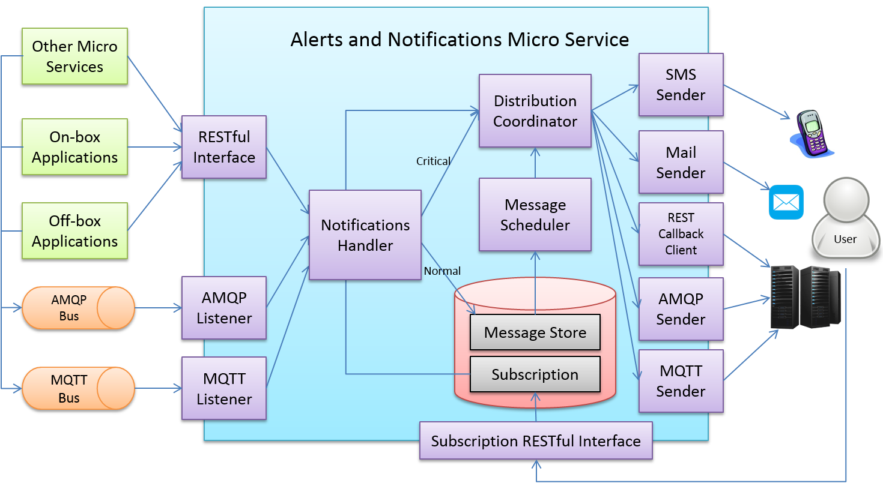

The diagram shows the high-level architecture of Alerts and Notifications. On the left side, the APIs are provided for other microservices, on-box applications, and off-box applications to use, and the APIs could be in REST, AMQP, MQTT, or any standard application protocols. Will be in SFx, the RESTful interface is provided.

On the right side, the notification receiver could be a person or an application system on Cloud or in a server room. By invoking the Subscription RESTful interface to subscribe the specific types of notifications, the receiver obtains the appropriate notifications through defined receiving channels when events occur. The receiving channels include SMS message, e-mail, REST callback, AMQP, MQTT, and so on. Will be in SFx, e-mail and REST callback channels are provided.

When Alerts and Notifications receive notifications from any interface, the notifications are passed to the Notifications Handler internally. The Notifications Handler persists the receiving notification first, and passes them to the Distribution Coordinator immediately if the notifications are critical (severity = “CRITICAL”). For normal notifications (severity = “NORMAL”), they wait for the Message Scheduler to process in batch.

The Alerts and Notifications is scalable, can be expanded to add more severities and set up corresponding Message Schedulers to process them. For example, the Message Scheduler of normal severity notifications is triggered every two hours, and the minor severity notifications is triggered every 24 hours, at midnight each night.

When the Distribution Coordinator receives a notification, it first queries the subscription to acquire receivers who need to obtain this notification and their receiving channel information. According to the channel information, the Distribution Coordinator passes this notification to the corresponding channel senders. Then, the channel senders send out the notifications to the subscribed receivers.

**Data Model**

MongoDB or similar is selected for the persistence of Alerts and Notifications, so the data model design is without foreign key and based on the paradigm of document structure.

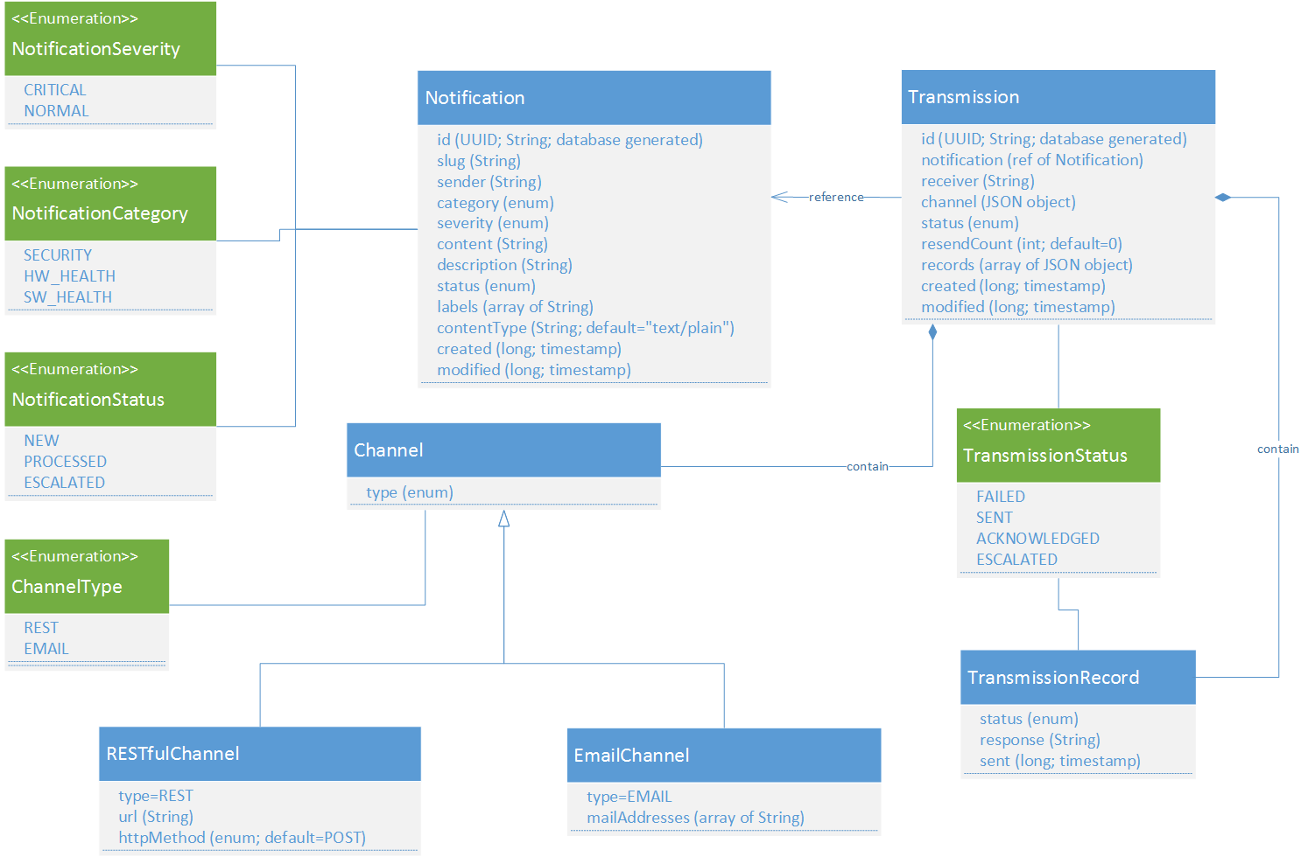

**Data Dictionary**

| **Class Name** | **Descrption** |
| --- | --- |
| Channel | The object used to describe the Notification end point. |
| Notification | The object used to describe the message and sender content of a Notification. |
| Transmission | The object used for grouping of Notifications. |

**High Level Interaction Diagrams**

This section shows the sequence diagrams for some of the more critical or complex events regarding Alerts and Notifications.

**Critical Notifications Sequence**

When receiving a critical notification (SEVERITY = “CRITICAL”), it persists first and triggers the distribution process immediately. After updating the notification status, Alerts and Notifications respond to the client to indicate the notification has been accepted.

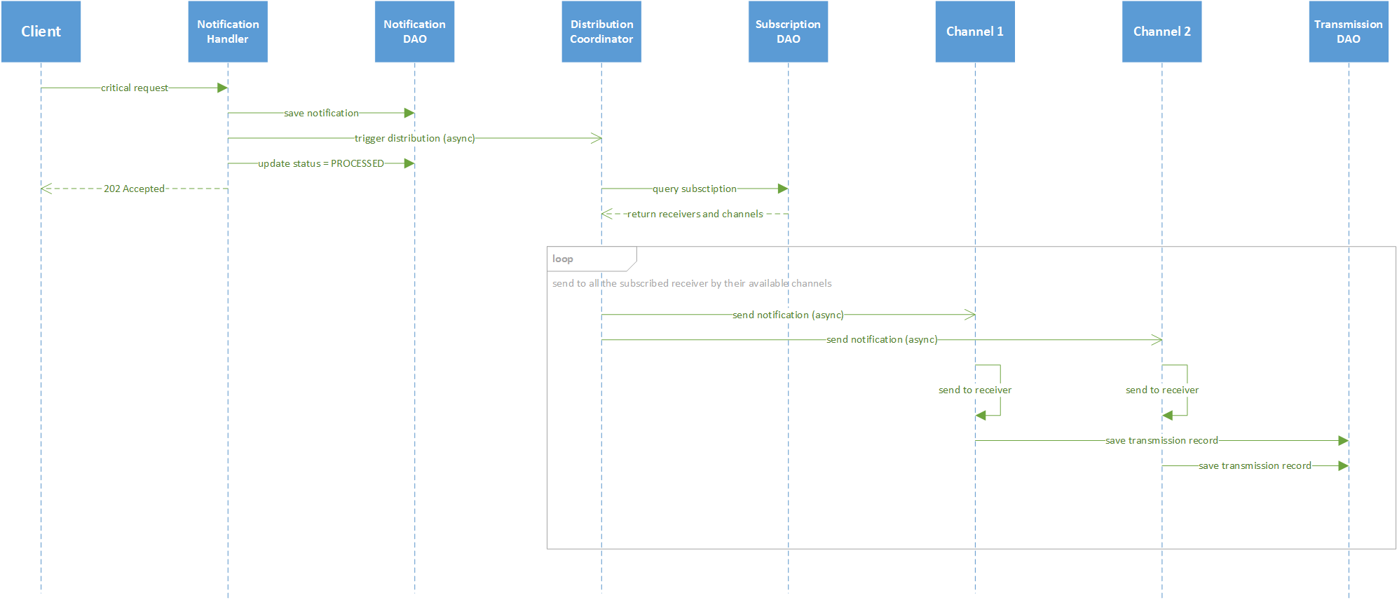

**Normal Notifications Sequence**

When receiving a normal notification (SEVERITY = “NORMAL”), it persists first and responds to the client to indicate the notification has been accepted immediately. After a configurable duration, a scheduler triggers the distribution process in batch.

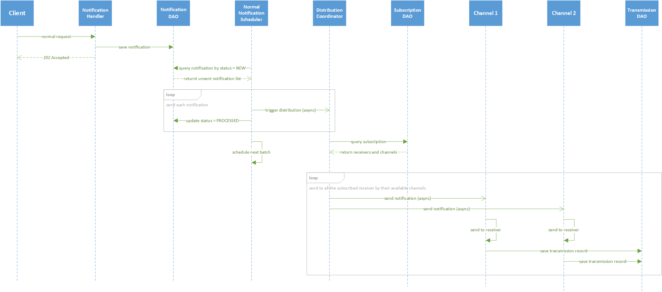

**Critical Resend Sequence**

When encountering any error during sending critical notification, an individual resend task is scheduled, and each transmission record persists. If the resend tasks keeps failing and the resend count exceeds the configurable limit, the escalation process is triggered. The escalated notification is sent to particular receivers of a special subscription (slug = “ESCALATION”).

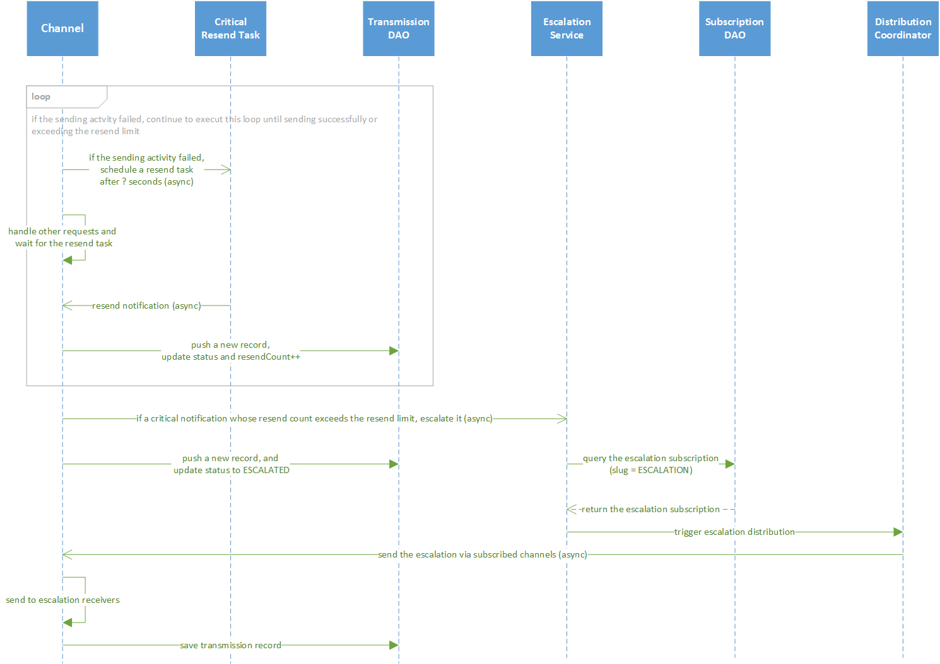

**Resend Sequence**

For other non-critical notifications, the resend operation is triggered by a scheduler.

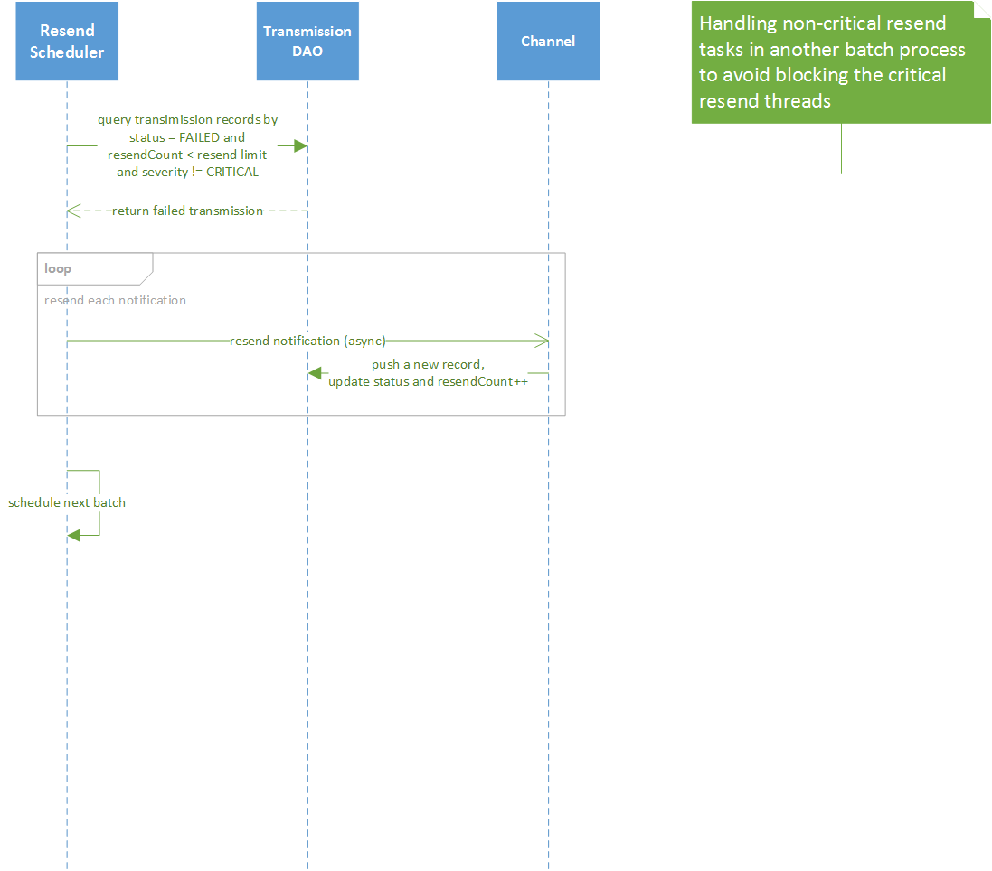

**Cleanup Sequence**

Cleanup service removes old notification and transmission records.

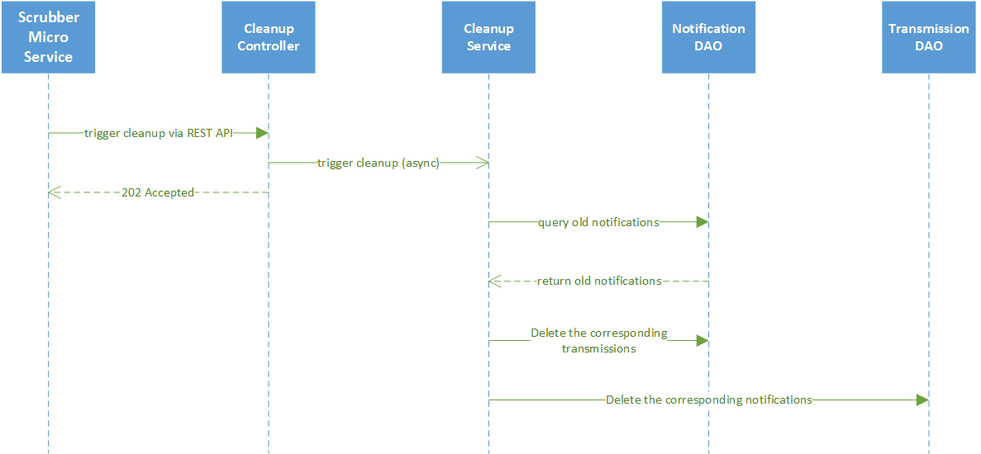

**Configuration Properties**

| **Configuration** | **Default Value** | **Dependencies** |
| --- | --- | --- |
| Service ReadMaxLimit | 1000 * | Read data limit per invocation |
| Service BootTimeout | 300000 * | Heart beat time in milliseconds |
| Service StartupMsg | This is the Support Notifications Microservice * | Heart beat message | |
| Service Port | 48060 ** | Micro service port number |
| Service Host | localhost ** | Micro service host name |
| Service Protocol | http ** | Micro service host protocol |
| Service ClientMonitor | 15000 ** |  |
| Service CheckInterval | 10s ** |  |
| Service Timeout | 5000 ** |  |
| ResendLimit | 2 * | Number of attempts to resend a notification |
| Following config only take effect when logging.persistence=file | | |
| Logging File | /logs/SFx-support-notifications.log| File path to save logging entries | |
| Logging EnableRemote | false | Indicate whether to use the logging service (vs local log file) |
| Following config only take effect when logging.persistence=database | | |
| Databases Database Primary Username | [empty string] ** | DB user name |
| Databases Database Password | [empty string] * | DB password |
| Databases Database Host | localhost ** | DB host name |
| Databases Database Port | 27017 ** | DB port number |
| Databases Database Database | logging * | database or document store name |
| Databases Database Timeout | 5000 * | DB connection timeout |
| Databases Database Type | mongodb ** | DB type |
| Following config only take effect when connecting to the registry for configuraiton info | | |
| Registry Host | localhost ** | Registry host name |
| Registry Port | 8500 ** | Registry port number |
| Registry Type | consul ** | Registry implementation type |
| Following config only take effect when connecting to the remote logging service | | |
| Clients Clients.Logging Host | localhost ** | Remote logging service host name |
| Clients Clients.Logging Port | 48061 ** | Remote logging service port number |
| Clients Clients.Logging Protocol | http ** | Remote logging service host protocl |
| Following config apply to using the SMTP service | | |
| Smtp Host | smtp.gmail.com ** | SMTP service host name |
| Smtp Port | 25 ** | SMTP service port number |
| Smtp Password | mypassword ** | SMTP service host access password |
| Smtp Sender | [jdoe@gmail.com](mailto:jdoe%40gmail.com) ** | SMTP service sendor/username |
| Smtp Subject | SFx Notification ** | SMTP alert message subject |

*means the configuration value can be changed if necessary.

**means the configuration value has to be replaced.

**Configure Mail Server**

All the properties with prefix “smtp” are for mail server configuration. Configure the mail server appropriately to send Alerts and Notifications. The correct values depend on which mail server is used.